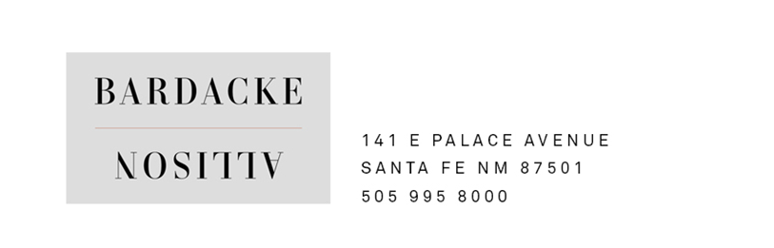
Nearby Local Restaurants

Around the corner:

Chez Mamou French 217 E Palace Ave 505.216.1845

Palacio Café New Mexican/sandwiches/burgers 209 E Palace Ave 505.989.3505

The Shed New Mexican 113 E Palace Ave 505.982.9030

Elōisa Creative New Mexican 228 E Palace Ave 505.982.0883

La Casa Sena New Mexican 125 E Palace Ave 505.988.9232

A couple of blocks away:

La Plazuela Best Huevos Rancheros 100 E San Francisco St 505.995-2334

The Beestro Great sandwiches/soups/salads (take-out) 101 W Marcy St 505.629.8786

Julia @ La Posada American/Southwestern 330 E Palace Ave 505.954.9670

A couple of miles away (but worth the drive):

Geronimo Global Eclectic (fine dining, dinner only) 724 Canyon Rd 505.982.1500

The Compound Contemporary American 653 Canyon Rd 505.982.4353

